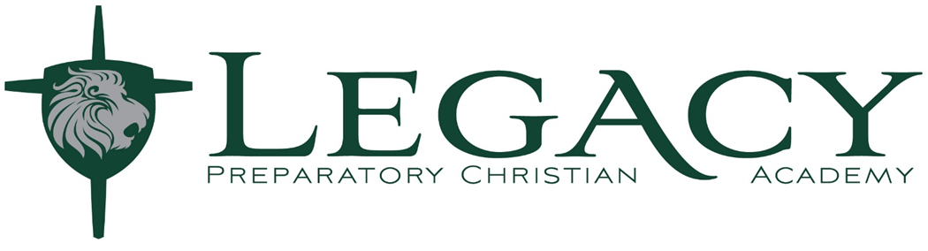
Technology Agreement Verification

I have read and agree to abide by the Technology Responsible Use Guidelines laid out by Legacy Preparatory Christian Academy.
Please PRINT Below:

Parent Name: ___________________________(PRINT) DATE:_____________________

Student Name: __________________________(PRINT) DATE:_____________________

Grade Level: ____________

